**SRS REPORT**

**T R A C E**

**SUBMITTED BY:**

A ARMAN

A VISHNU

GOUTHAM VS

SANGEETH G S

NARENDRAN M

**TEAM GUIDE :** SHAMNA AL

**COLLEGE:** COLLEGE OF ENGINEERING MUTTATHARA

**DEPARTMENT:** COMPUTER SCIENCE & ENGINEERING

**Tracking and Recognition of Activity Certificates and**

**Events**

**[TRACE]**

**1. INTRODUCTION**

TRACE is a website that provides an intuitive interface integrated with a database to store and manage various activity certificates and allocate points from a student end, verification and provide a collective representation of the data in an organized format from a teacher’s end and manage and provide functionalities regarding an **interactive telegram chat-bot** for retrieval and updation of documents and data.

**1.1. PURPOSE**

* The project seeks to streamline the certificate and activity point management process, making it easier for students, tutors, and administrators to manage and access their records.
* It integrates with the app an interactive telegram chat bot for ease of uploading and monitoring of data for the user.

**1.2. SCOPE**

* TRACE is a software system that aims to provide an intuitive interface integrated with a database to store and manage various activity certificates and allocate points from a student end.
* TRACE aims to provide verification and a collective representation of the data in an organised format from the teacher’s end.
* TRACE manages and provides functionalities regarding an interactive telegram chat-bot for retrieval and updation of documents and data.
* The purpose of TRACE is to provide a comprehensive solution for managing student activities and data in an efficient and organised manner.

**1.3. Definition, Acronyms, Abbreviation**

* **SQL -> Structured query Language**
* **DFD -> Data Flow Diagram**
* **CFD -> Context Flow Diagram**
* **ER -> Entity Relationship**
* **CSS -> Cascading Style Sheets**
* **SRS -> Software Requirement Specification**
* **PHP -> Hypertext Preprocessor**
* **HTML -> Hypertext Markup Language**

**2**. **OVERALL DESCRIPTION**

**2.1. FUNCTIONAL REQUIREMENTS**

1. Registration and Login for various individuals.
2. Uploading certificates by category.
3. Automatic calculation of activity points.
4. Manual correction and verification functions in Teacher’s login.
5. Basic functionalities accessible through telegram bot.
6. Batch download of certificates as zip.

**2.2. SOFTWARE REQUIREMENT**

**Front end:**

* HTML
* CSS
* JAVASCRIPT

**Back end:**

* MySQL or NoSQL or MongoDB
* PHP
* NodeJS
* ExpressJS

**Operating System :** Any OS that supports a web browser.

**2.3. HARDWARE REQUIREMENT**

* Computer with a 1.1 GHz or faster processor
* Minimum 2GB of RAM

**2.4. USER CHARACTERISTICS**

**We have 3 levels of users :**

1. **ADMIN :**
2. **STUDENT LOGIN :**
3. **TEACHER LOGIN :**

**2.5. PROCESS SPECIFICATION**

* **User Registration**
  + Users can create accounts providing their college id, contact details and setting a password that fulfills the criterion.
* **UI Navigation**
  + Provides different panes for viewing status, uploading documents and managing status and personal dashboard.
  + Users can simply upload certificates selecting respected categories of events and let the app allocate maximum points allotted to the events by KTU guidelines.
* **Feedback System**
  + Users can submit suggestions, generate bug reports and the app itself will generate and manage accurate crash logs.
* **Support**
  + The UI will be providing a separate help pane for quick tutorials and also provide customer support contact details.

**FLOW DIAGRAM**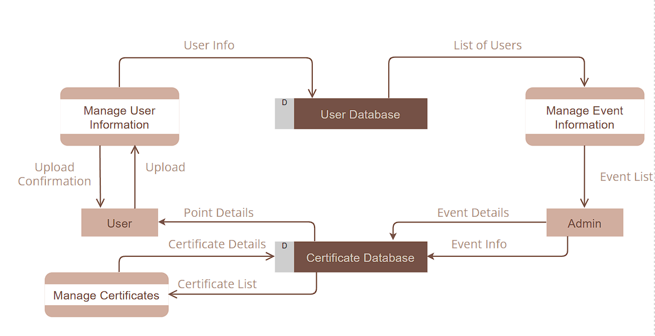

**USE CASE DIAGRAM**

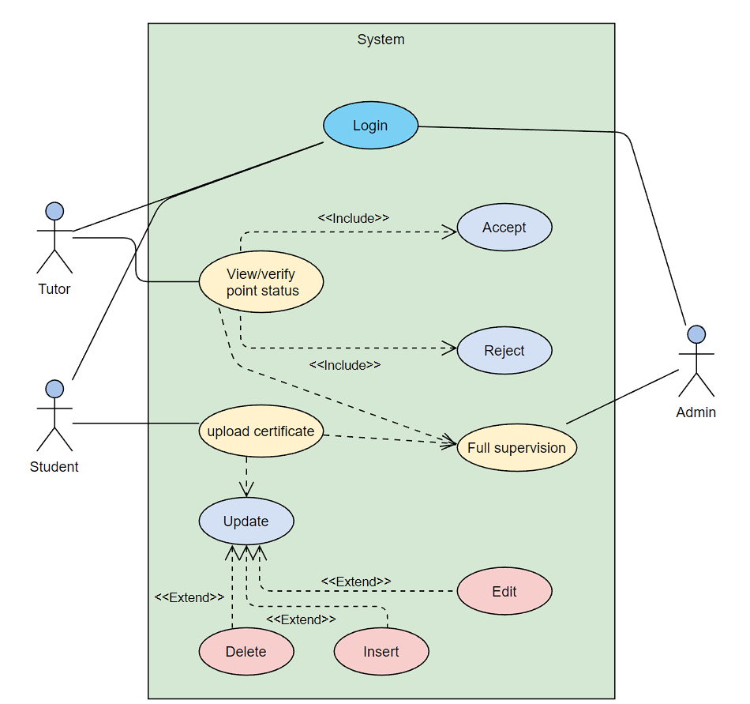

**CLASS DIAGRAM**

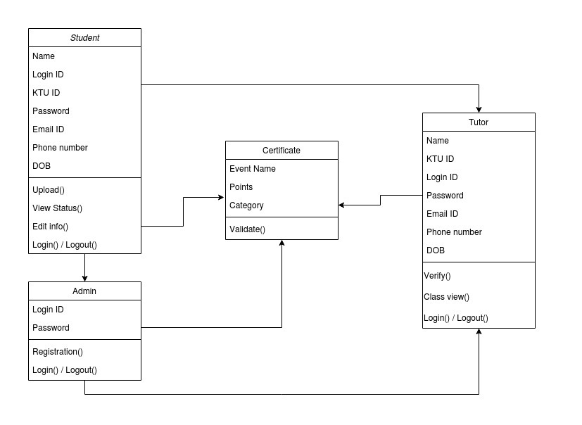

**ACTIVITY DIAGRAM**

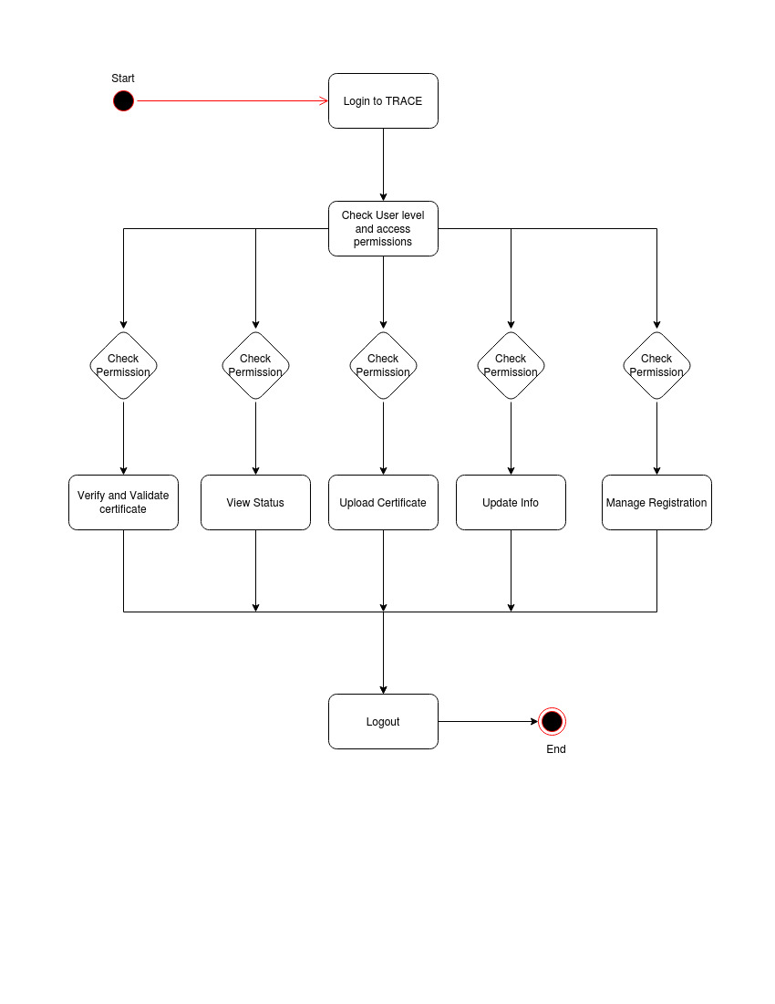

**ER DIAGRAM**

